QQ-plots in R, first need to understand the Q-Q plot. The Q-Q plot is a graphical tool to help us examine if a set of data plausibly came from some theoretical distribution such as a Normal or not.

Suppose, if we are executing a statistical analysis the test comes under parametric methods assumes variable is Normally distributed, we can make use of a Q-Q plot to check that assumption.

It’s just a visual verification, not full proof, so we can make use of some other statistical test also. But Q-Qplot allows us to see at-a-glance if our assumption is valid or not.

Basically, a Q-Q plot is a scatterplot created with the aid of using plotting units of quantiles towards one another.

If each unit of quantiles got here from the identical distribution, we have to see the factors forming a line that’s more or less straight.

Here we are going to discuss an example of a Normal Q-Q plot when both sets of quantiles come from Normal distributions.

**QQ-plots in R**

We are making use of mtcars package in R.

head(mtcars)

mpg cyl disp hp drat wt qsec vs am gear carb

Mazda RX4 21.0 6 160 110 3.90 2.620 16.46 0 1 4 4

Mazda RX4 Wag 21.0 6 160 110 3.90 2.875 17.02 0 1 4 4

Datsun 710 22.8 4 108 93 3.85 2.320 18.61 1 1 4 1

Hornet 4 Drive 21.4 6 258 110 3.08 3.215 19.44 1 0 3 1

Hornet Sportabout 18.7 8 360 175 3.15 3.440 17.02 0 0 3 2

Valiant 18.1 6 225 105 2.76 3.460 20.22 1 0 3 1

Make a plot for the variable mpg, **qqnorm** function produces a normal QQ plot of the variable

qqnorm(mtcars$mpg, pch = 1, frame = FALSE)

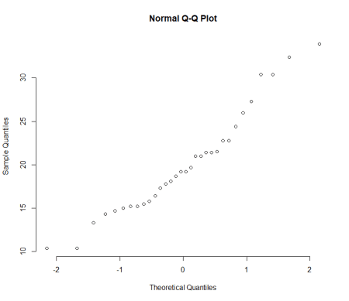

Add a line to the plot, **qqline** function adds a reference line

qqline(mtcars$mpg, col = "steelblue", lwd = 2)

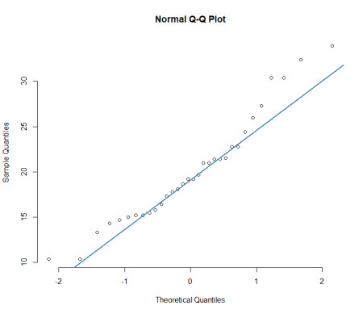

More or less points are closer to the straight line.

**qqPlot** function also avilable from car package, Let’s see how to plot the same.

library(car)

qqPlot(mtcars$mpg)

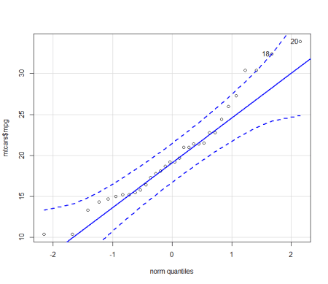

qqPlot function provides better visualization compared to previous one. Almost all points fall approximately along this straight line, so we can assume normality.

Let’s see how to plot the same in ggplot.

library(ggplot2)

ggplot(mtcars, aes(sample=mpg))+stat_qq()+theme_bw()

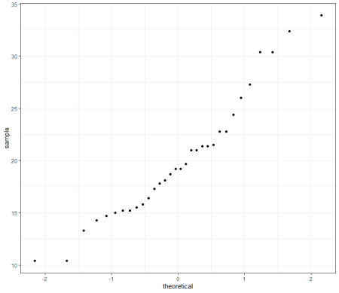

We can make use of qplot function also,

qplot(sample = mpg, data = mtcars)+theme_bw()

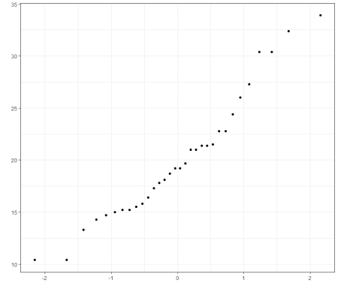

We can change qq plot point shapes by groups

Create Q-Q plot based on groups

p<-qplot(sample = mpg, data = mtcars, color=cyl)+theme_bw()

p

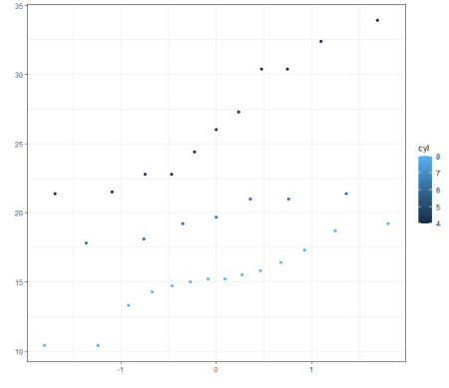

You can legend position to different places.

p + theme(legend.position="top")

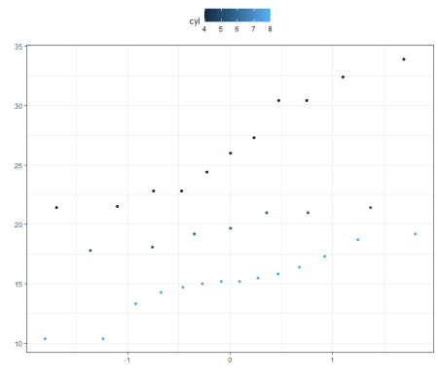

p + theme(legend.position="bottom") # legend at bottom

p + theme(legend.position="left") #legend at left

p + theme(legend.position="none") # Remove legend

The result you got from Q-Q plot you can verify the same based on **shapiro** test.

shapiro.test(mtcars$mpg)

Shapiro-Wilk normality test

data: mtcars$mpg

W = 0.94756, p-value = 0.1229

The result is not significant, so we can assume the normality.